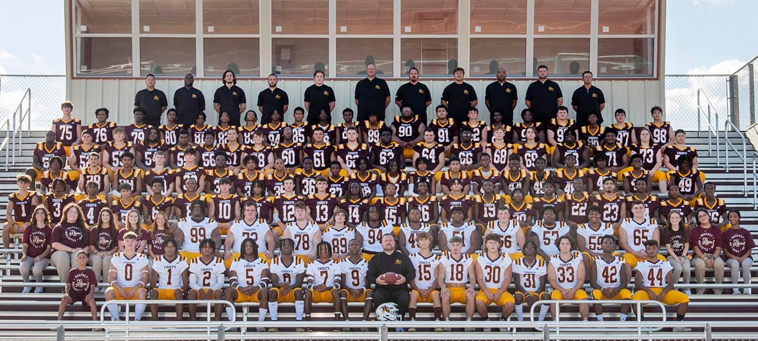
Chiefs travel to scrimmage Pineville as regular season draws near
PINEVILLE, La. - The Natchitoches Central Chiefs football team continues their preparation for the 2023 regular season under first-year head coach Jess Curtis Friday in a scrimmage against the Pineville Rebels on the road at 7 p.m.
NCHS is less than three weeks from the season opener when they will face Woodlawn-Shreveport Friday, Sept. 1 on the road. Prior to, the Chiefs will compete in the Natchitoches Regional Medical Center Jamboree Friday, Aug. 25 at Turpin Stadium in Natchitoches against Loyola Prep at 8 p.m.
Friday’s gridiron affair will include approximately 60 plays from scrimmage with no official score being kept. Admission for the game is $5.

