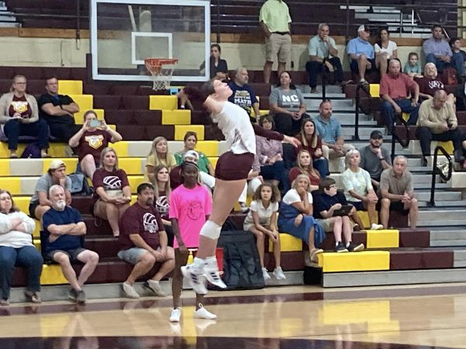
NCHS Volleyball Team Defeats Benton in Straight SEets
(Senior Lora Cole Smashes 11 Kills as Lady Chiefs roll past Benton)
The Natchitoches Central Lady Chiefs’ volleyball team got 11 kills from senior Lora Cole as it defeated Benton 25-23, 25-11 and 25-16 Tuesday in a scrimmage at NCHS.
NCHS, under third year head coach Kerri Kiracofe, also were aided with six kills from Ainsley Weeks and Maggie Dunn.
“There are things we need to clean up before our scrimmage (on Thursday),” said Kiracofe. “But other than the few little things, everyone played their roles tonight and executed it well.”
The Lady Chiefs will face Byrd Thursday at 4 p.m.,5 and 6 as the freshmen, junior varsity and varsity will all be in action.
Fans interested in attending can purchase tickets at the Go Fan App and search Natchitoches Central.

