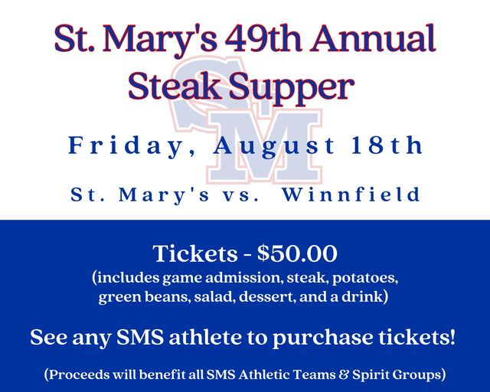
SMH to host 49th annual Steak Supper Scrimmage
The St. Mary’s Tigers football team will host it 49th annual Steak Supper scrimmage Friday night at 7 p.m. at the St. Mary’s practice field located behind the school.
The Tigers will host both Grant and Winnfield with SMH playing one half against each team as they continue preparation for the 2023 season. The Tigers, under sixth-year head coach Aaron York, open the season Friday, Sept. 1 at home against Abbeville.

